Name : Arini Puspitasari

Class : Web Programming A

NRP : 05111740000040

REPORT

* Navigation

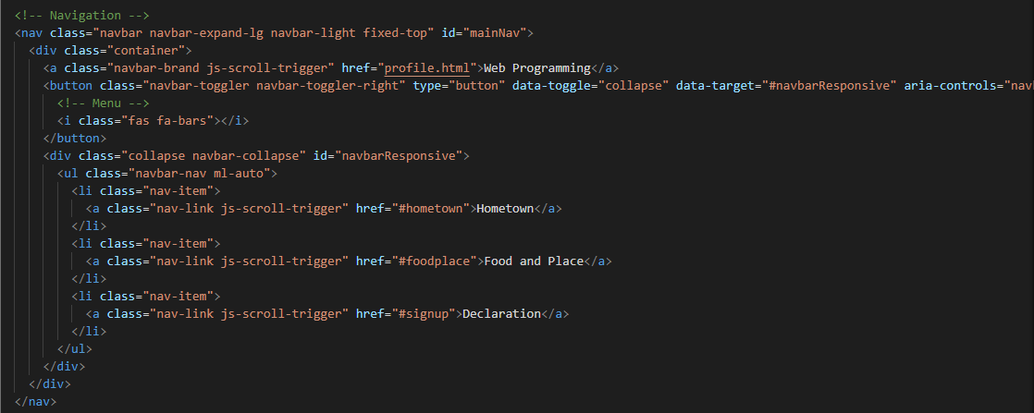

I give a title in above left corner “Web Programming” and there are three menu on the above right corner, they are hometown, food and place, and the last is declaration.

The result is :

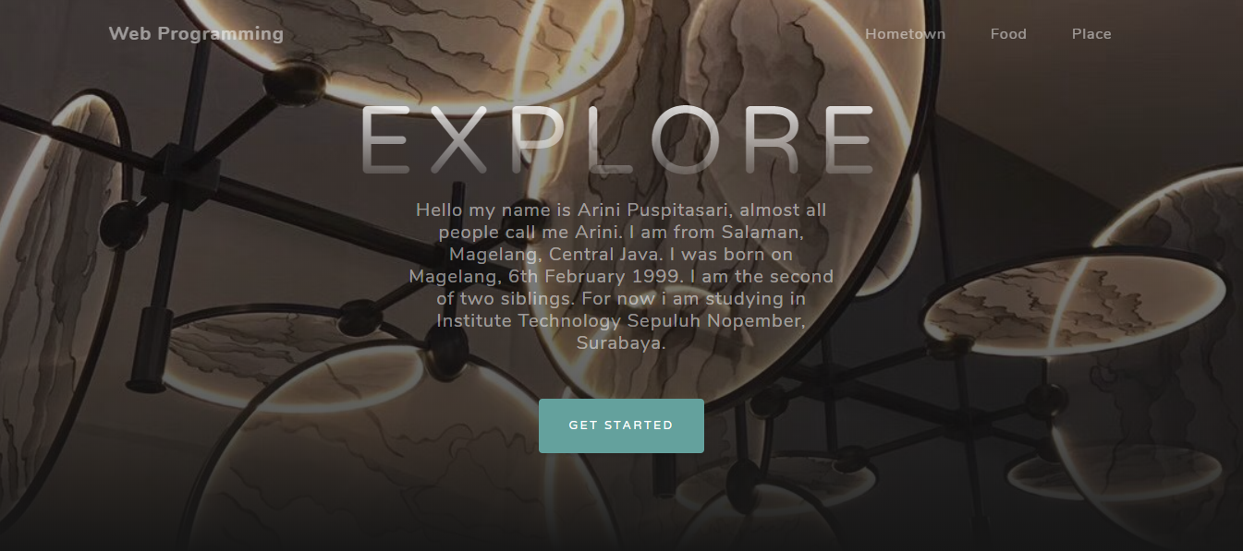

* Header

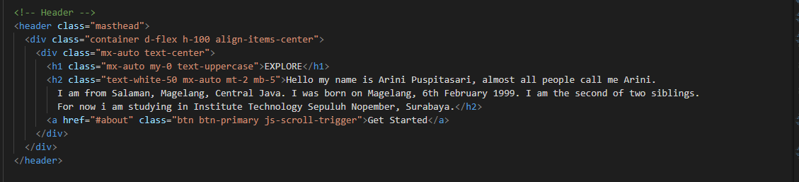

This is the initial display, in this section I use it to write my profile and also I give the button for the next page or section.

The result is :



* Home town

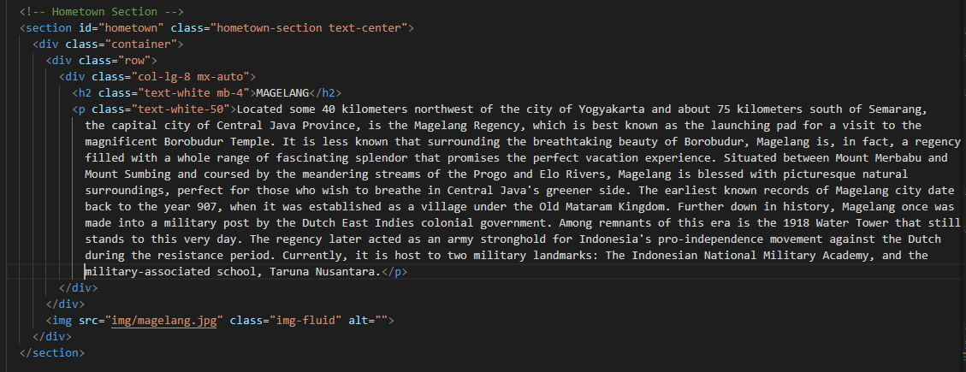

On this section I use to explation or give the declaration about my home town and also not forget to give the title too. Beside that I give a photo that related to my explanation about my hometown.

The result is :

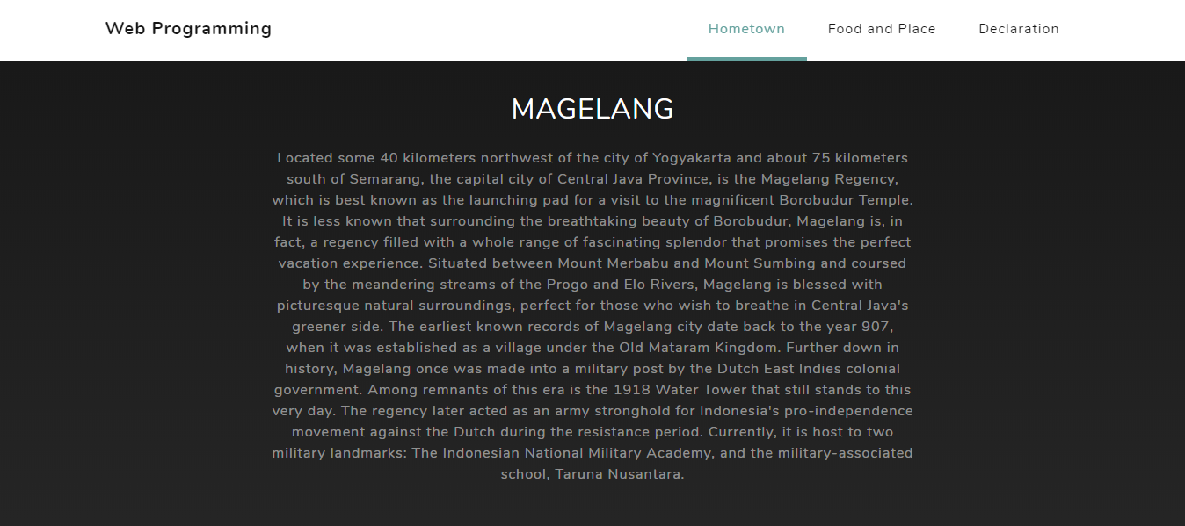

The photo is under the explanation.:

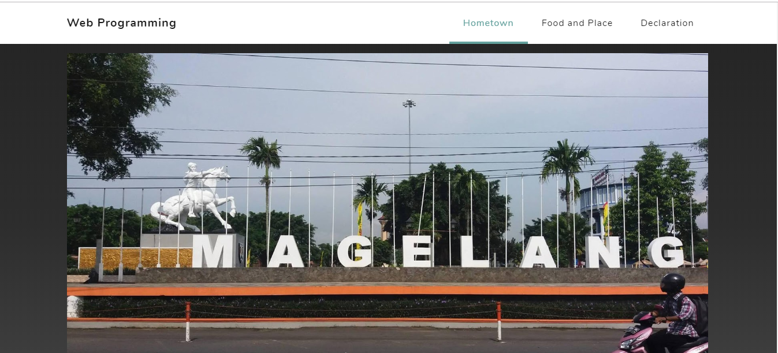

* Food

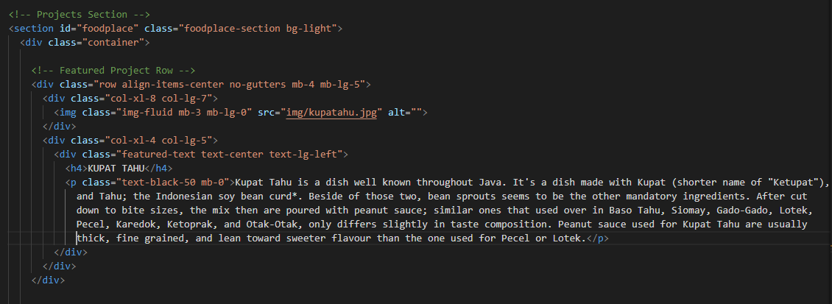

In this section I write about the local food which name is Kupat Tahu, I give the title and photo too.

The result is :

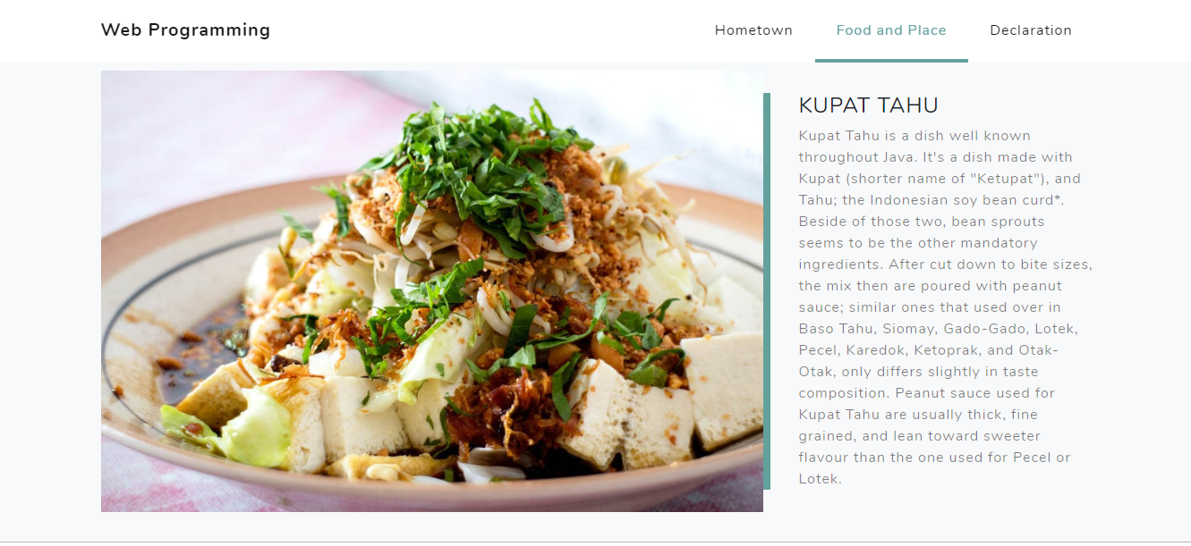

* Place

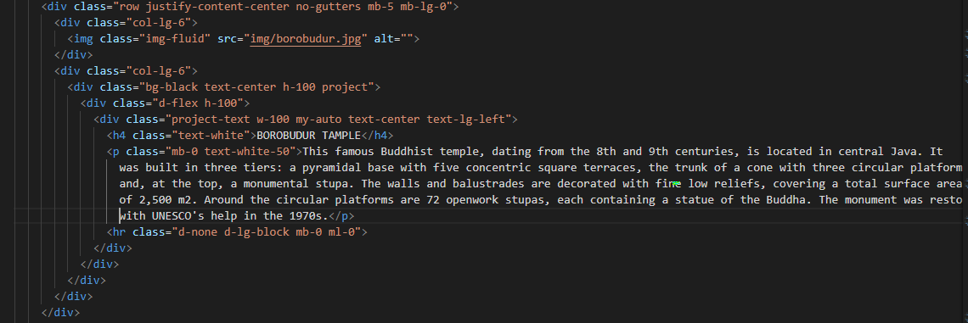

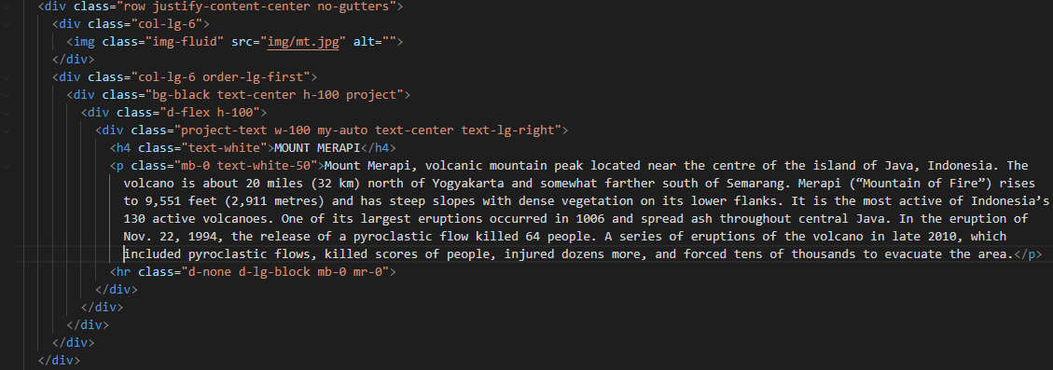

I write two tourist place that must be visited. The first one is Borobudur Tample, the famous Buddhist Tample. And the second one is Mount Merapi that all of them are located in Magelang. Ofcourse in this section I write the explanation and the title, and not forget to give the photo on each place.

The result is :

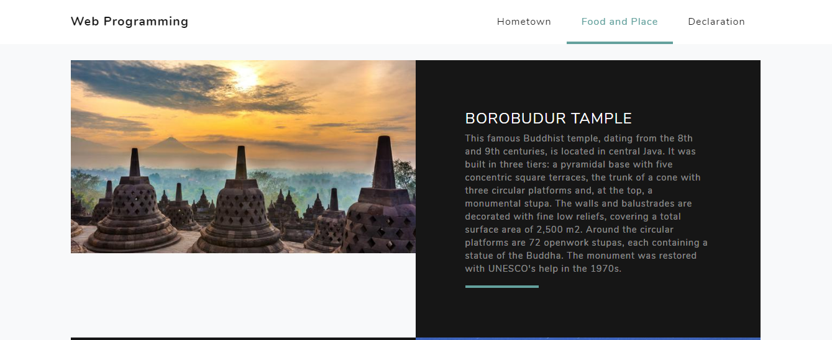

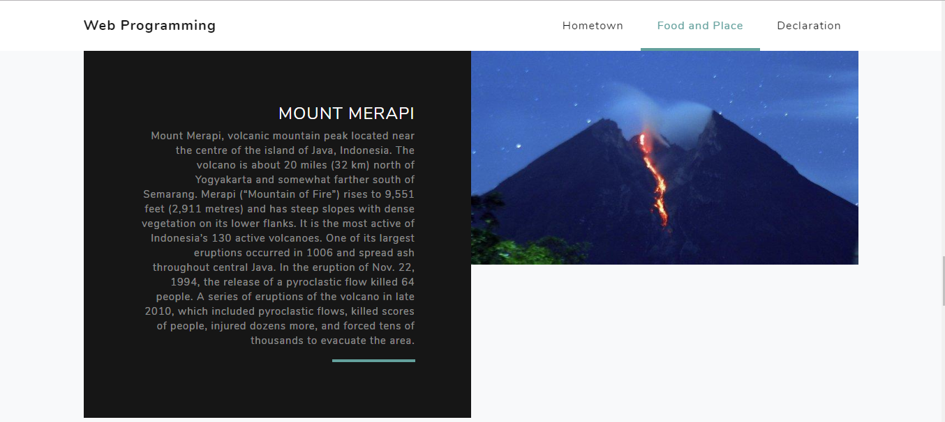

* Declaration

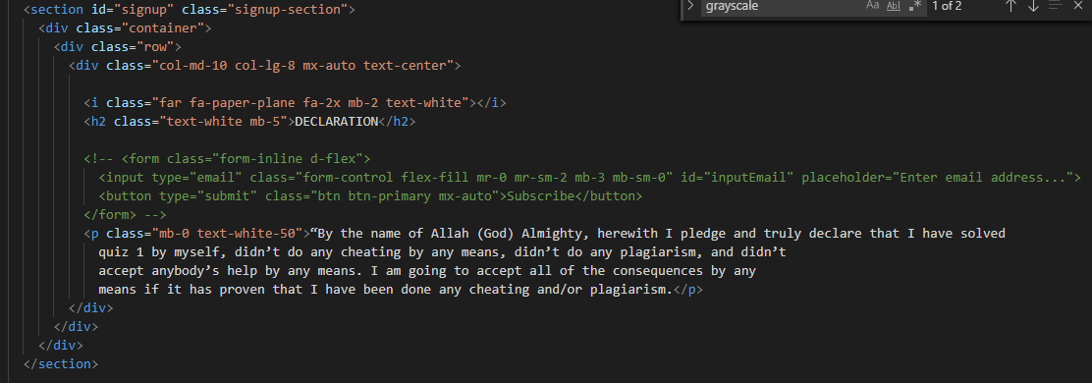

The last one is declaration, the explanation that I am not do cheating on this quiz.

The result is :

